Fishbone Diagram Template
Use this worksheet to define a quality problem, brainstorm possible causes by category, and decide what evidence to check next.
Template ID | 8DF-FBT-01
Revision | 1.0
Format | Microsoft Word DOCX
Intended use | General manufacturing fishbone / cause-and-effect worksheet

Purpose
This is a thinking tool, not proof of root cause. Use it to list possible causes, then check evidence before confirming occurrence root cause, escape point, or corrective action.

Quick facilitation steps
Meeting flow
1) Agree one narrow effect. 2) Use the categories. 3) Add possible causes, not fixes. 4) Add short why/sub-cause notes under the strongest ideas. 5) Move the strongest causes into the cause review table and verify them with evidence.

Category note
The classic 5M categories are Person, Method, Machine, Material, and Environment. This template uses manufacturing-friendly wording and adds Measurement / Inspection because many customer issues also need an escape or detection review.

Use it when | A simpler note may be enough when | Move on to RCA / 8D when
The problem could have more than one cause. | The cause is obvious, low risk, and already supported by evidence. | The issue is customer-facing, repeat, high cost, safety-related, or requires formal corrective action.
You need input from production, quality, maintenance, inspection, or supplier quality. | A small internal correction is enough and no customer response is needed. | You need to document confirmed root cause, containment, corrective action, verification, and effectiveness.
The team is jumping straight to a favourite answer. | The record only needs a short factual note and action owner. | The fishbone points to likely causes that require 5 Whys, 8D D4, NCR, CAR, or SCAR follow-up.

Suitability note
Provided for general manufacturing quality use. Adapt this template to your company, customer, product, process, and industry requirements. This template is not intended for medical device, pharma, FDA, Part 11, or validated regulated workflows.

1. Problem / Effect Definition
Completion guidance
State the problem in factual, measurable terms. Do not include assumed root cause. The effect you write here becomes the head of the fishbone diagram.

Issue details
Issue ID / NCR / 8D reference |  | Date opened
Customer / internal source |  | Owner / facilitator
Part / product |  | Part number / revision
Lot / batch / serial / date code |  | Shift / time window (optional)
Process / work area |  | Where made / produced
Where found |  | Requirement source
Affected quantity |  | Suspect quantity
Physical location of suspect stock |  | Stock isolation / hold area
Containment status |  | Containment owner

Problem statement
Problem / effect to investigate
Requirement not met
Actual condition found
When and where it was detected
Known facts only
Example wording
Good problem statement example: "Customer returned 18 bracket assemblies from lot B2417 because one mounting bolt had no visible threadlocker. Requirement WI-ASM-014 calls for blue threadlocker on both mounting bolts."

2. Main Fishbone Worksheet
Possible causes only. Use primary cause lines first, then add short why/sub-cause notes. Confirmed root cause belongs in follow-up RCA, 5 Whys, 8D, NCR, CAR, or SCAR work after evidence has been checked.
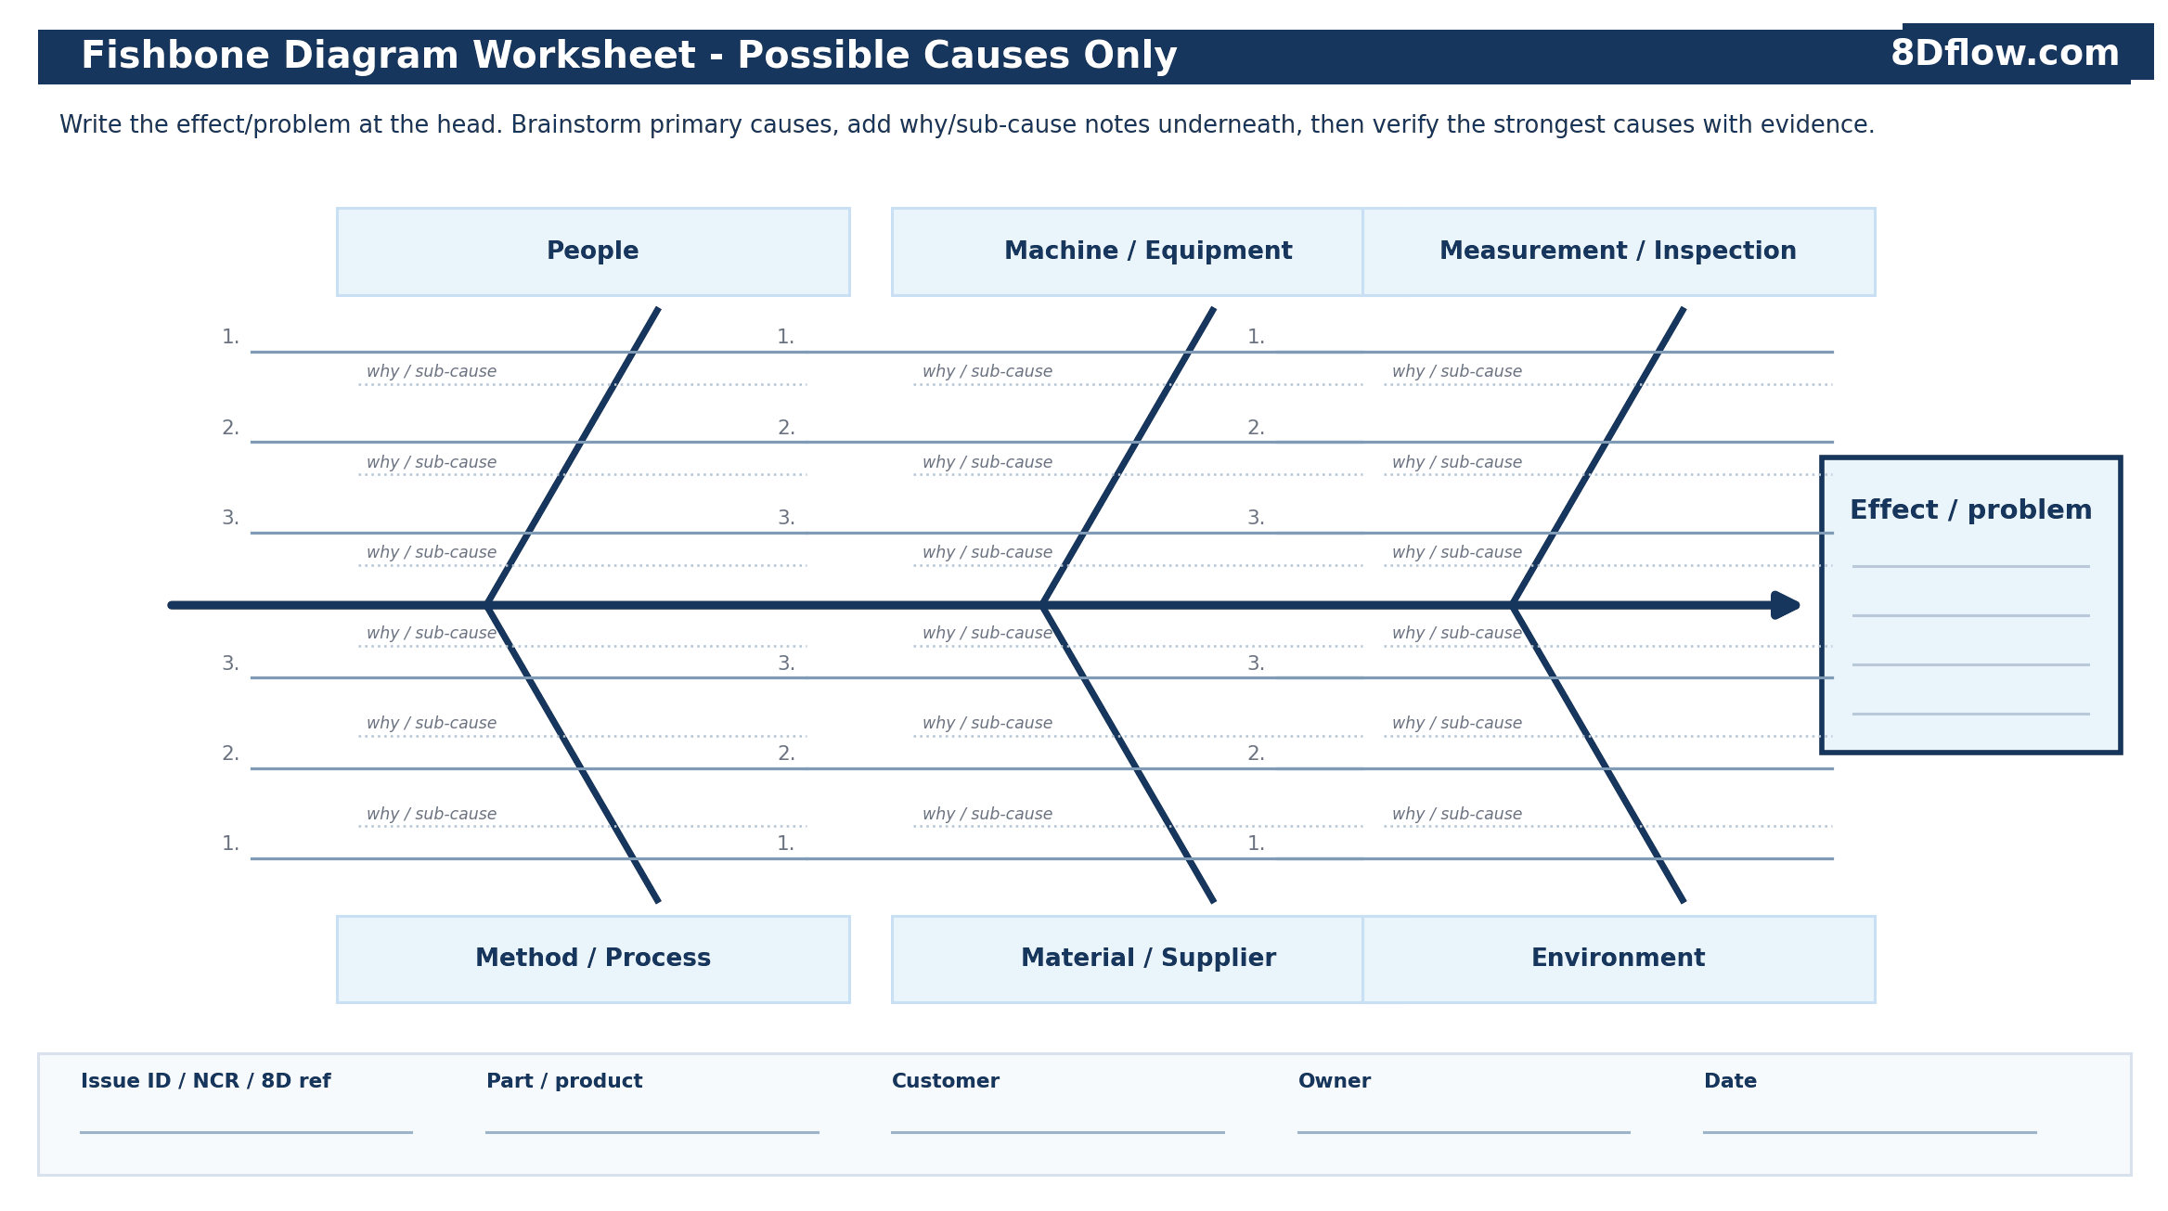

3. Cause Review
Completion guidance
Transfer the strongest primary causes and sub-causes from the fishbone into this table. Do not delete weak or contradicted ideas too early - mark them with evidence so the team can see what was checked.

Possible cause / sub-cause | Category | Evidence needed / record ID or link | Evidence result / status | Priority / next step | Notes

Evidence prompts
Done | Check before closing the fishbone session
☐ | Check the actual part, lot, batch, inspection record, test result, photo, measurement, or returned sample where available.
☐ | Separate what people remember from what the record, part, or process evidence shows.
☐ | Keep causes separate from potential solutions until evidence supports the root cause path.
☐ | Look for both occurrence causes and escape / detection weaknesses.
☐ | If a cause is contradicted by evidence, mark it as contradicted instead of quietly removing it.
☐ | Move the highest-priority supported cause into 5 Whys, 8D D4, NCR, CAR, or SCAR follow-up as needed.

4. Investigation Next Steps
Completion guidance
This section turns the brainstorm into investigation work. It should not become the corrective action plan until root cause has been supported by evidence.

Cause to investigate next  © 8Dflow.com - For internal adaptation only. | Why it is likely | Evidence needed / record ID or link | Owner | Due date | Manual cross-reference ID (5 Whys / 8D / NCR)

Quick decision record
Most likely occurrence cause to check first | Write the one cause the team has most reason to believe based on what is known so far - not opinion.
Possible escape point / detection failure | Where should this defect have been caught? Why was it not detected?
Evidence that must be gathered before root cause is confirmed
Next method to use | ☐ 5 Whys ☐ 8D D4 ☐ NCR ☐ CAR ☐ SCAR ☐ Other: __________  This section is a manual team record for deciding which follow-up method or external record should be used next.
Decision owner / date

5. Completed Example
How to read this example
The example shows a practical team brainstorm. It includes one cause that is later contradicted by evidence so the fishbone is treated as a thinking record, not a guessing contest.

Example problem definition
Issue ID / NCR / 8D reference | NCR-24-118 / 8D-24-032 | Date opened | May 14
Customer / internal source | Customer return - North line | Owner / facilitator | Quality Engineer
Part / product | Stamped bracket assembly | Part number / revision | BRK-4472 Rev C
Lot / batch / serial / date code | Lot B2417 | Shift / time window (optional) | Day shift, after break cover
Process / work area | Assembly cell A3 | Where made / produced | Plant 2 - assembly
Where found | Customer receiving inspection | Requirement source | WI-ASM-014 Rev C
Affected quantity | 18 returned assemblies | Suspect quantity | 420 assemblies in lot B2417
Physical location of suspect stock | Internal suspect stock in quarantine cage Q-2 | Stock isolation / hold area | Customer stock held; internal stock sorted
Containment status | Customer stock held; internal stock sorted | Containment owner | Production Supervisor

Problem statement
Customer returned 18 stamped bracket assemblies from lot B2417 because one mounting bolt had no visible blue threadlocker. Work instruction WI-ASM-014 Rev C requires blue threadlocker on both mounting bolts before final torque.

Completed Example Fishbone
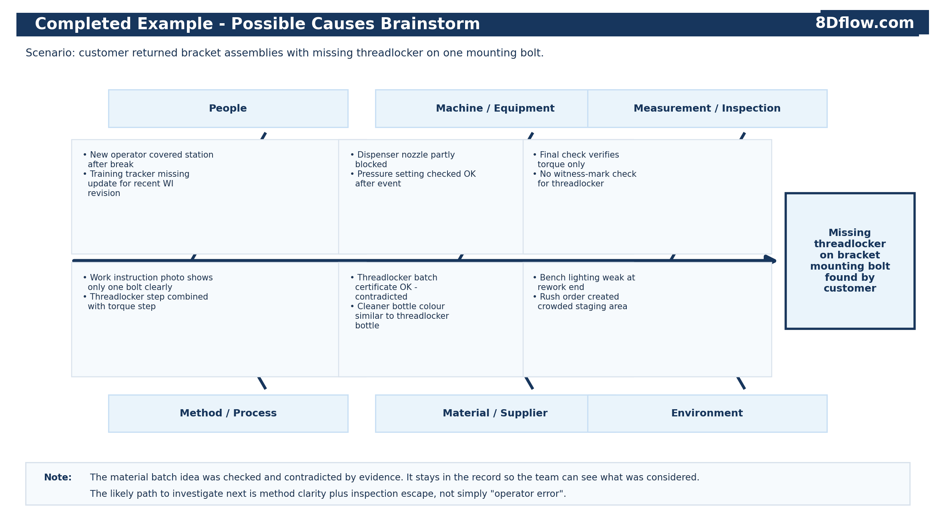

Completed Example - Cause Review
Possible cause / sub-cause | Category | Evidence checked / record ID or link | Evidence result / status | Priority / next step | Notes
Work instruction photo shows only one bolt clearly | Method / Process | WI-ASM-014 Rev C; operator interview; station photo IMG-118-02 | Supported - second bolt not visible in work instruction image | High - run 5 Whys | Method clarity
Final inspection checks torque only | Measurement / Inspection | Inspection checklist QI-147 and final audit record FAR-24-118 | Supported - no visual witness-mark check | High - investigate escape | Detection weakness
Threadlocker batch defective | Material / Supplier | Batch certificate, expiration date, receiving record, retained sample | Contradicted - batch in date and passed sample test | Close as checked | Keep in record
Dispenser nozzle partly blocked | Machine / Equipment | Maintenance check and dispense test after hold | Needs checking - low volume observed on first purge | Medium - verify | Maintenance owner
Training tracker missing update for recent WI revision | People | Roster, training tracker, interview notes | Needs checking - operator trained on old revision | Medium - check change control | Do not stop at operator error
Bench lighting weak at rework end | Environment | Area walk-through and photo IMG-118-05 | Supported as contributing factor, not enough by itself | Low / contributing | Include in action review

Example next step
The team should not close this as "operator error." The supported path to investigate is method clarity plus inspection escape: why the work instruction allowed one bolt to be missed, and why final inspection did not detect missing threadlocker before shipment.

6. Common Mistakes
Practical reminder
A useful fishbone keeps the team honest. It helps show what was considered, what evidence was checked, and where the next investigation should go.

Mistake | Why it causes trouble | Better approach
Writing the assumed root cause at the start | The team stops looking for other causes. | Start with the factual effect. Confirm root cause only after checking evidence.
Using the fishbone as proof | A brainstorm is not evidence. | Use the cause review table to show what evidence supports or contradicts each cause.
Listing solutions instead of causes | The diagram becomes an action plan before the team knows what caused the problem. | Keep branches as possible causes. Put fixes into the corrective action plan later.
Stopping at operator error | It usually misses method, training, inspection, fixture, tooling, or management-system weaknesses. | Ask what allowed the error to happen and why it was not detected.
Listing causes with no evidence plan | The record becomes opinion-based. | Assign evidence, owner, and due date for the most likely causes.
Mixing containment with corrective action | Sorting, holds, and replacement product do not explain why the problem happened. | Record containment separately, then investigate root cause.
Ignoring escape / detection failure | The occurrence cause may be fixed while the detection gap remains. | Ask where the defect should have been caught and why it escaped.
Failing to connect to 5 Whys or 8D D4 | The fishbone stays as a meeting note and no action follows. | Move supported causes into 5 Whys, 8D, NCR, CAR, SCAR, or corrective action follow-up.

Close the session with these checks
Done | Check before closing the fishbone session
☐ | The problem statement is factual and does not include assumed root cause.
☐ | Possible causes are grouped under practical manufacturing categories.
☐ | At least one likely occurrence cause and one possible escape / detection weakness have been considered.
☐ | Evidence has been assigned for the strongest possible causes.
☐ | Contradicted causes are marked rather than quietly removed.
☐ | Next steps have owner, due date, and a manual cross-reference ID for 5 Whys, 8D, NCR, CAR, SCAR, or corrective action follow-up where needed.

Use 8Dflow.com
Tracking owners, due dates, and evidence across Word files and email threads gets messy fast. 8Dflow is manufacturing quality software for managing 8D reports, NCRs, corrective actions, owners, due dates, and evidence in one place. Visit 8Dflow.com.

